St. Francis 800 Jubilee novena 25th September – 3rd October
Our Parish of KilnamanaghCastleview will be holding a Novena to celebrate the 800 Anniversary of the life and legacy of St. Francis of Assisi.There will be a series of events including Mass, Guest Speakers, a Prayer Walk and the Blessing of Animals. 
This Novena celebration is part of The Season of Creation which is celebrated annualy from September 1st to October 4th. This year the theme is “Living Water”
There are posters in both of our churches with all the details (times, places,speakers etc). There are flyers to take home. If you wish to contribute to the costs involved, please take an envelope provided, at the back of each church. You can return them to the Sacristy or Parish office.
Feast of the Exaltation of the Holy Cross.
Mass will take place in St. Kevin’s Church next Monday 14th September at 10.00am to celebrate the Feast of the Exaltation of the Holy Cross. We are blessed in our parish to have a Relic of the One True Cross. It is in St. Kevin’s Church and all are welcome to come and visit the Relic.
Bethany Bereavement Group will resume its monthly gathering next Monday 14th September at 12.00noon. The meeting takes place in the room at the rere of St. Kilian’s Church. The group are trained volunteers who provide a confidential listening ear to all those suffering the loss of a loved one. The meeting is held on the 2nd Monday of each month.
Crosscare, The annual collection for Crosscare takes place on the weekend of September 19/20 in place of the usual Share collection the social support agency of the Archdiocese of Dublin, Every day Crosscare works alongside families worried about losing their home, young people in need of guidance and support, people experiencing homelessness, and migrants and refugees seeking safety and a fresh start.The theme of this year’s appeal is Hope & Resilience. It reflects the remarkable courage shown by the people Crosscare serves every day and the hope made possible through the generosity of parish communities.

Society of St. Vincent De Paul will be holding their monthly out door collection after all Masses this weekend. All the contributions you make, stay locally, to help all those in need. Many thanks for your ongoing support.

.

Mass Times and Services
Mass Schedule
Weekdays
Tuesday St. Kilian’s 10.00 am
Wednesday 10.00 am
St. Kevin’s, Thursday 10.00am
(Hospitality after Mass)
Friday 10.00 am
St. Kilian’s, 10.00am
(Hospitality after Mass)
Sundays
6.00 p.m. Vigil – St. Kilian’s, Kingswood.
10.00 a.m. – St. Kevin’s, Kilnamanagh
12 noon -St. Kilian’s, Kingswood
Contact Information
Parish Administrator:
Fr. Frank Drescher
Parish Sister: Sr. Liz Byrne
01-4515570
Parish Secretary: Annette O Dwyer
Parish Office @ St. Kevin’s Church
Tel. 01-4515570
Office Hours: Monday, Tuesday, Thursday & Friday
10.30 a.m. – 2.30 p.m.
Email: kcparishoffice@gmail.com
Website: www.kilnamanaghcastleview.com
Facebook: www.facebook.com/Kilnamanagh
CastleviewParish

24th Sunday of
Ordinary time
Alleluia
Speak, Lord, your servant is listening:
You have the message of eternal life
Alleluia
Feast of the Exaltation of the Holy Cross
Monday 14th September
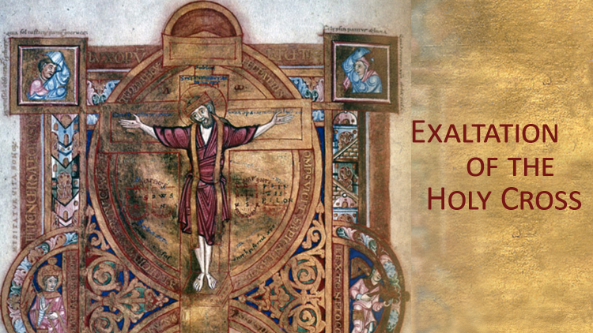
O God, who willed that your Only Begotten Son should undergo the Cross to save the human race, grant, we pray, that we, who have known his mystery on earth, may merit the grace of his redemption in heaven. Through our Lord Jesus Christ, your Son, who lives and reigns with you in the unity of the Holy Spirit, God, for ever and ever.

