Visio Divina – Exercise: The Transfiguration, by Carl H. Bloch (c. 1865)

- Preparation: Begin by finding a quiet space where you can sit comfortably without distractions. Take a few deep breaths to centre yourself, inviting the Holy Spirit to guide your meditation.

- Opening Prayer: You may say a prayer asking God to open the eyes of your heart, to let you perceive beyond the visual elements and to understand the spiritual message conveyed through the image. You could, for example, use the following words:
Lord, as I gaze upon this image, open the eyes of my heart to the message it holds. Help me to see with more than my eyes, to understand with more than my mind. May this time of reflection bring me closer to you. Amen.

- Seeing with Attention: Study the whole image—the composition, the interplay of light and shadow, the characters, and the atmosphere. Look at the central figure of Christ in radiant white, the prophets at his sides, and the apostles below, especially their expressions and gestures.

- Seeing with Intention: Direct your focus to a detail within the painting that captures your attention. It could be the divine light surrounding Christ or the awe on the apostles' faces. Consider why this detail is meaningful to you and what it reveals, for instance, about the dual nature of Jesus as both the divine Son of God and the prophesied Son of Man, a truth revealed at the moment of the Transfiguration.

- Responding: Reflect on your emotional and spiritual response to the image. What does this portrayal of the Transfiguration stir within you? Speak to God about your feelings, as if you were conversing with a friend. If moved to do so, write down your thoughts and prayers.

- Resting: Rest in God's presence, either with eyes closed or fixed on the image. Allow the emotions and thoughts that have arisen during your meditation to settle in your heart.

- Closing Prayer: Conclude with a prayer of thanks for the insights received and ask for the grace to carry the lessons of the Transfiguration—such as the revelation of Christ's divine glory and the call to listen to him—into your daily life. You could, for example, say:
Gracious God, thank you for this time to see your Word through art. May the lessons of faith, hope and transformation I have received today be inscribed on my heart and made visible in my life. Amen.

Copyright:

Fr. Frank Drescher, Adm.,
Parish of St. Kevin and St. Kilian,
Kilnamanagh-Castleview, Dublin.
Lent, 2024.

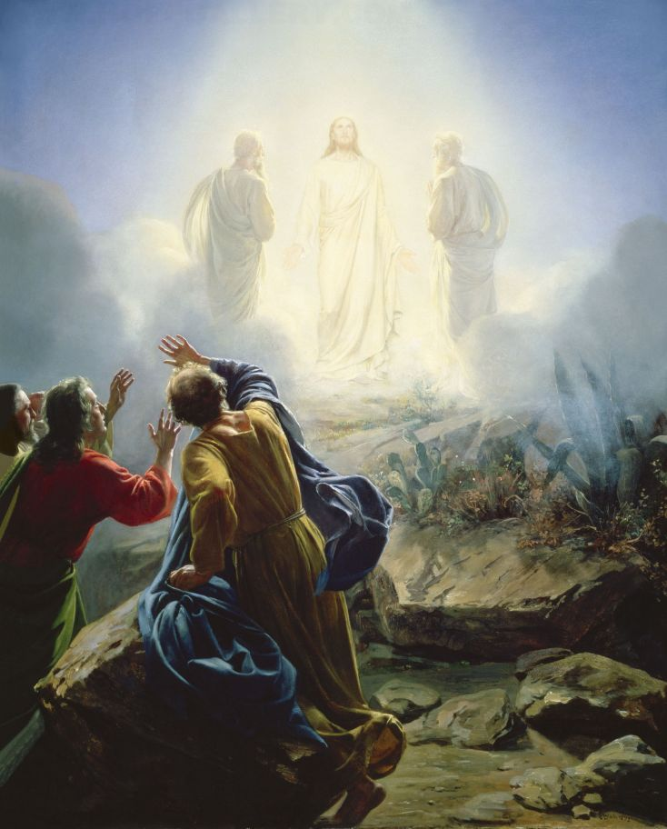
The Transfiguration, by Carl H. Bloch (c. 1865)

