Today, I want to talk to you about a lovely form of prayer which is called visio divina. This is Latin and means, ‘divine seeing’. It’s a way of praying with pictures or images, especially those from the Bible, to help us see and understand God’s word in a new way. Now, how does it work?

Think about your favourite picture book or a beautiful painting you’ve seen. When you see a picture that really catches your attention, you don’t just look at it quickly and then walk away, right? You look very closely, very carefully at all the little details, and sometimes, you even imagine yourself in the scene!

Visio Divina is similar, but we use sacred images, for example, pictures from the Bible. It’s a way to ‘read’ these images slowly, as we would read a story, think deeply about them, and let them speak to our hearts.

Today’s Gospel reading, taken from Mark’s Gospel, is a wonderful story for Visio Divina. It’s about a very special event in Jesus’ life, known as the Transfiguration. This is another complicated word coming from Latin and means as much as a great change of form or appearance. This happened when Jesus went up a high mountain with three of his best friends – Peter, James, and John. There, something amazing happened: Jesus’ clothes became very bright and shiny, dazzling white, and two great figures from the Old Testament, Moses and Elijah, appeared and talked with him.

Now, let’s try Visio Divina with the Transfiguration. First, we look at an image of this story. Observe the scene: Jesus glowing with light, the prophets Moses and Elijah beside him, and the disciples in surprise and amazement. Notice everything in the picture – the colours, the expressions on their faces, and the bright light around Jesus.

Then, we think about what this image means to you. What part of the picture stands out to you, what do we like best? Maybe it’s the bright light around Jesus, showing he is very special. This scene tells us that Jesus is not just a teacher; he is God’s own Son who came down from heaven to us!

Next, we talk to God about what we see. You can say a prayer like, ‘God, help me understand why Jesus was shining’, or ‘Help me feel the amazement the disciples felt’.

After that, we just sit quietly and look at the picture for a little while. Sometimes when we’re quiet, we can feel or understand things a bit better, or perhaps even in a new way. Maybe you’ll feel happy knowing Jesus is so amazing, or you might think of ways to show others how special Jesus is.

Visio Divina as a way of prayer helps us see Bible stories in a new way. It’s not just about seeing with our eyes, but with our hearts too. The Transfiguration is an amazing story because it shows Jesus in a way nobody had seen before, including his best friends. He’s more than just a regular person; he is truly special!

So, this week, why not find pictures of the Transfiguration, or another Bible story, and try praying with it using Visio Divina? It’s a great way to feel closer to God and to understand more about Jesus and his love for us.

Let’s remember, just like we can read the Bible every day, we can also look at sacred pictures and let them speak to our hearts. As we continue to go through the season of Lent, let’s be like the disciples on the mountain: full of wonder at seeing Jesus in a new light and ready to share the special story of God’s love with everyone we meet. Amen.

Copyright:

Fr. Frank Drescher, Adm.,
Parish of St. Kevin and St. Kilian,
Kilnamanagh-Castleview, Dublin.
Lent, 2024.
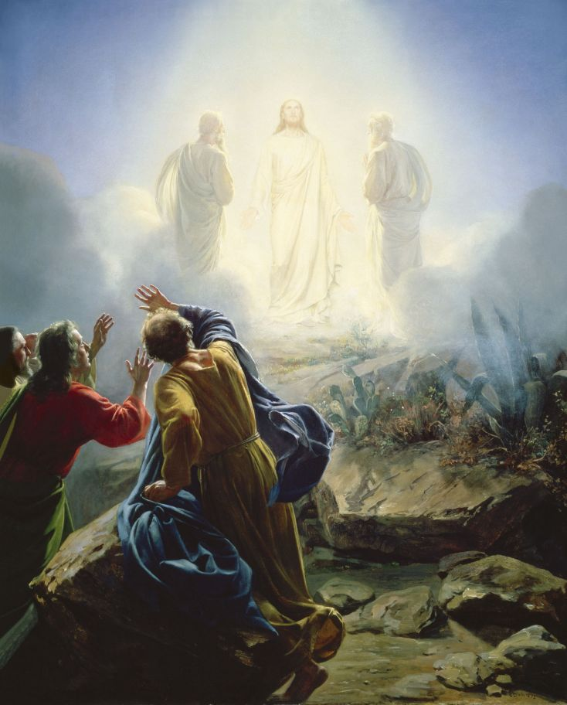
The Transfiguration, by Carl H. Bloch (c. 1865)

